- SUM OF INTEGERS
AIM
To write a Prolog program to find the sum of integers from 1 to N using recursion.
OBJECTIVE
- To understand recursion in Prolog.
- To calculate the sum of integers from 1 to N.
- To implement the program using Prolog predicates.
ALGORITHM
- Start.
- Read the value of N.
- Set the base case: sum(0,0).
- For N > 0, calculate N1 = N - 1.
- Recursively calculate the sum up to N1.
- Add N to the previous sum.
- Display the final sum.
- Stop.
Flowchart:
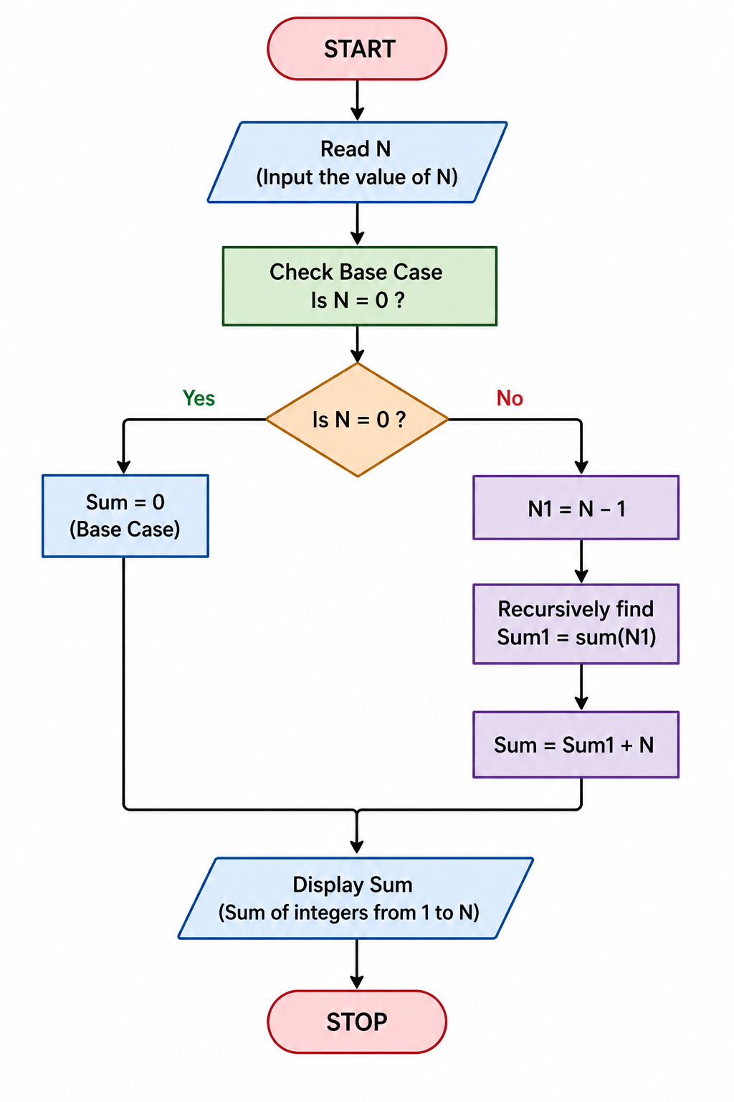
CODE:
sum(0, 0).
sum(N, Sum) :-
N > 0,
N1 is N - 1,
sum(N1, Sum1),
Sum is Sum1 + N.
OUTPUT:
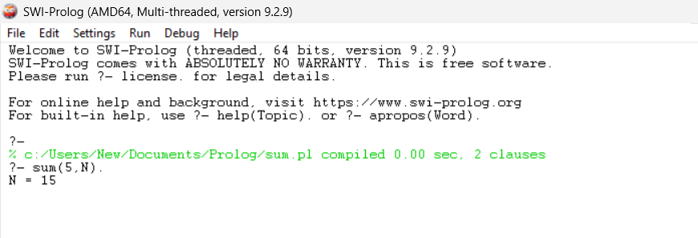
RESULT:
Thus, the Prolog program to calculate the sum of integers from 1 to N was successfully implemented and executed using recursion.

